**Difference between WCF and Web API**

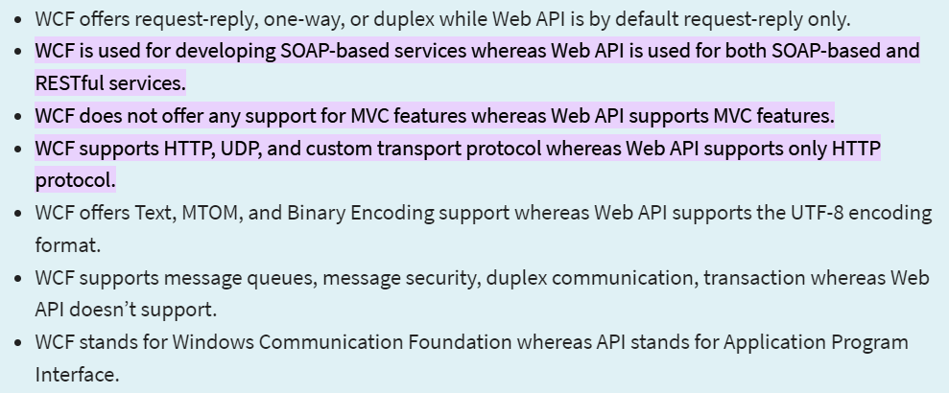

Why Use WCF?

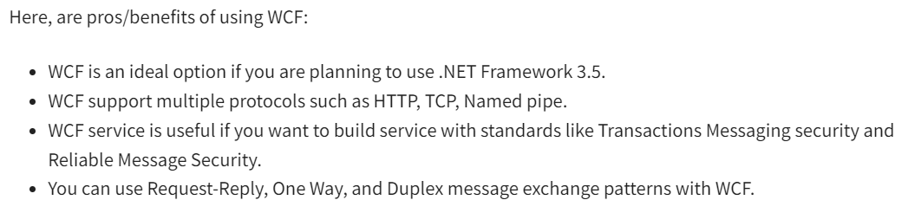

Why Use Web API?

